**D15B/34 Mikil Lalwani Advance DevOps**

**Assignment 1**

**Aim -**

o Part 1: To develop a website and host it on your local machine on a VM.

o Part 2: To host the website developed as part 1 of Assignment 1 using AWS.

**Theory-**

Part 1: To develop a website and host it on your local machine on a VM.

1. Install Xampp.
2. Provide admin-level access to Xampp i.e “run as administrator”.
3. Run Xampp and start Apache.
4. To check whether the web server is working or not open the browser and search localhost.
5. Go to C:\xampp\htdocs and create a new folder.
6. Create an index.html file in this folder.
7. Now write and save the file.
8. Open browser and search localhost/<folder-name>/ .

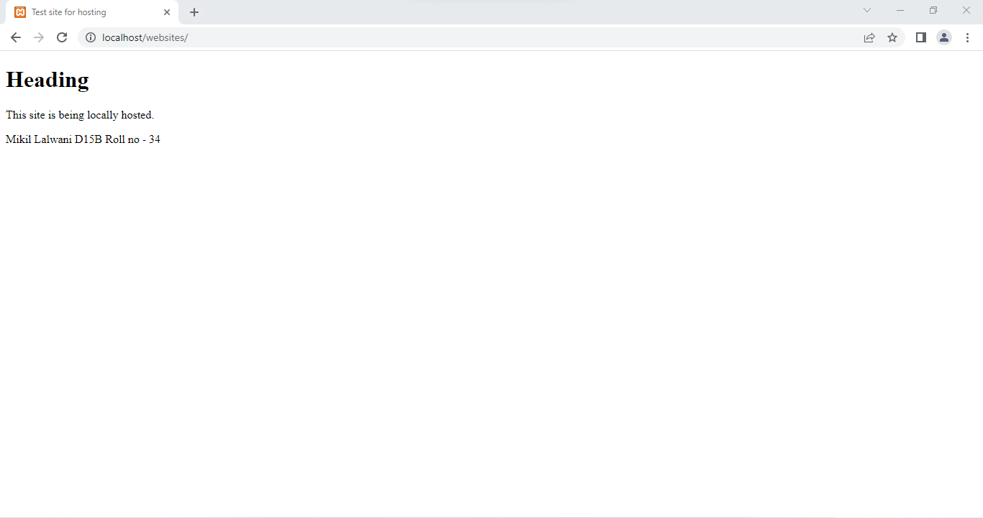

Part 2: To host the website developed as part 1 of Assignment 1 using AWS.

1. Login to AWS.
2. Search S3.
3. Click on create a bucket.
4. Provide it with a name and uncheck ‘Block all public access’.
5. Your bucket is now created.
6. Click on your bucket name and go to properties.
7. Scroll all the way down and click on edit in Static website hosting.
8. Click on enable and provide index.html as the Index document.
9. Click on save changes.
10. Click on upload and drag and drop the index.html file and click on upload.
11. Now go to the Properties tab in your bucket and click on the edit bucket policy.
12. Paste the content of the policy and click on save changes.
13. Go to properties and scroll down to Static website hosting.
14. The website URL is present there.
15. The website is now hosted on the AWS cloud.

